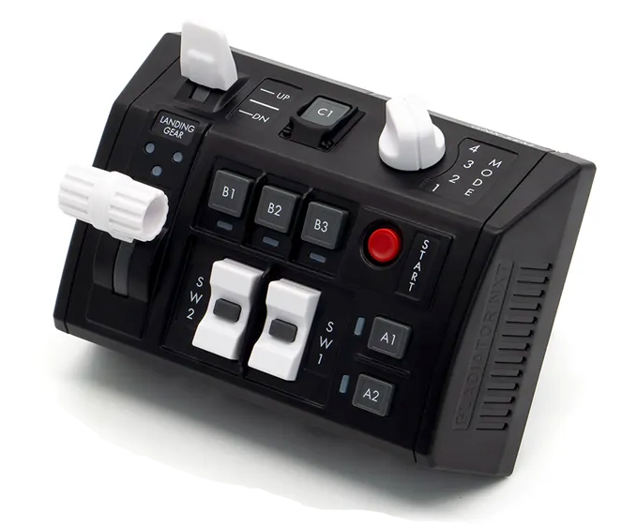  1xx - Controls | 2xx - Ground | 3xx - Flight | 4xx - A2A | 5xx - A2G | 6xx - Misc
104 - Controls - Pilot - GNX SEM-V
U=Up, D=Down, N=Neutral, F=Forward, B=Backward, L=Left, R=Right, P=Press, S-*=Shift-*, L-*=Long-*

Landing Gear
- U: Landing gear up
- N: --
- D: Landing gear down
Flaps Switch
- U: Flaps up
- N: --
- D: Flaps down
SW1 Rocker Switch
- U: Canopy open/close
- P: --
- D: Canopy open/close
SW2 Rocker Switch
- U: --
- P: --
- D: --
- S-U: Air-to-air Door Slipway Open
- S-P: Call "Ready for precontact"
- S-D: Air-to-air Door Slipway Close
Start Button
- P: --
A1 Button
- P: --
- S-P: --
A2 Button
- P: --
- S-P: --
B1 Button
- P: --
B2 Button
- P: --
B3 Button
- P: --
C1 Button
- P: --
Mode Knob
- 1: --
- 2: --
- 3: --
- 4: --

